Persistence of Vision Lightsaber

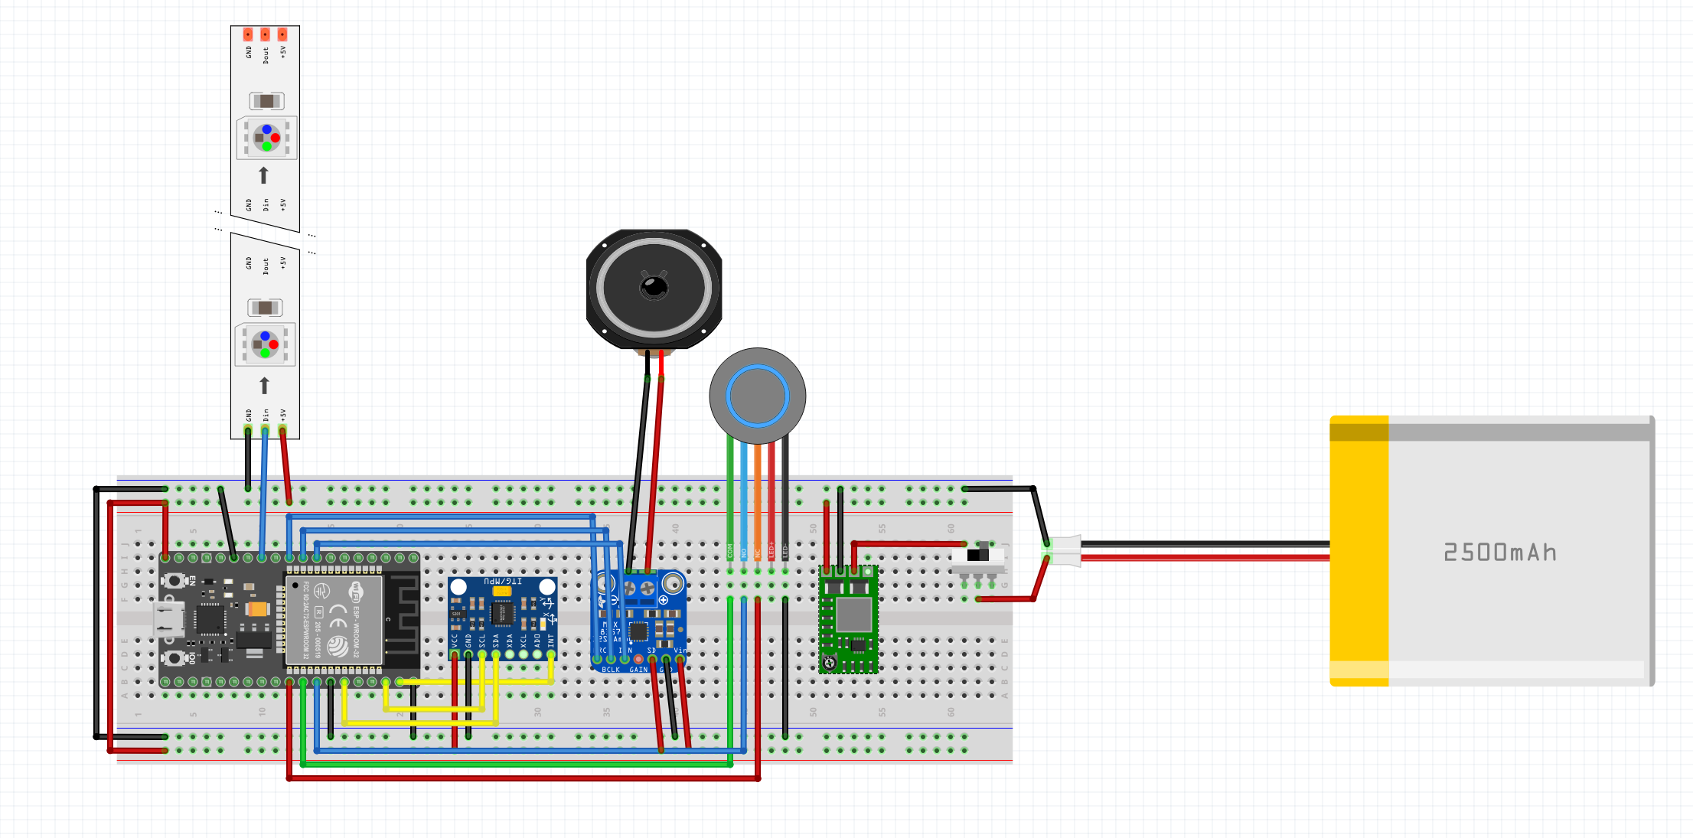

Power Supply
11.1v (3S1P) battery
- Use a buck converter to provide 5V to ESP32, MPU6050, etc
- Use 12V WS2815 LEDs (can run directly from battery)
3.7v (1S) battery
- Use a voltage regulator to provide stable 3.3V to the RP2040
- Use 5V WS2812B LEDs
- Use a level shifter to ensure the data line is referenced to the LED supply rail, so the LEDs see valid logic levels

LEDs
- Use 5V WS2812B LEDs or 12V WS2815 LEDs based on power supply
- Use dense 144 pixels/m version
- 4 pin JST connector with enough wire to install

Processor
- ESP32 3.3V or 5V
  - 25.9mm x 48.2mm (20mm clearance underneath)
- RP2040 3.3V

MPU
MPU-6050 Module 3-Axis Acceleration Gyro 6DOF Module 3V to 5V power
- 20.3mm x 15.7mm
- Has 3-axis accelerometer + 3-axis gyroscope so you can orientation data (roll, pitch, yaw) – needed for POV feature
- Has DMP to offload sensor fusion logic from CPU

Audio
MAX98357 BGA I2S 3W Class Amplifier Breakout 2.5 to 5V power
- 20.32mm x 17.78mm
- digital input so you can play stored or generated audio clips with little noise
PAM8403 Super mini digital amplifier board 2.5 to 5V power
- 15.8mm x 16.6mm
- analog input so you can generate frequencies dynamically using DACs or PWM

Power Button
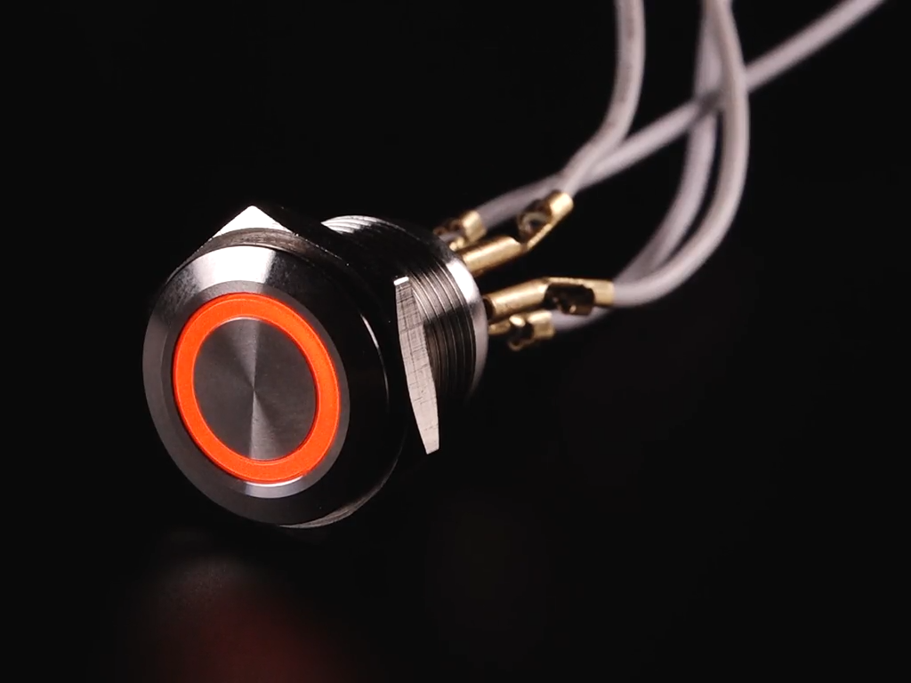
4 pin JST connector (LEDs) with enough wire to install
2 pin JST connector (button) with enough wire to install
- or -
Screw Terminal Block
On the back there are two gold contacts for the button and 4 for the RGB LED ring (one anode and 3 cathodes for each red, green, and blue). Power the anode at 3-6V and light up the red, green, and blue LEDs by pulling their designated contacts to ground as you desire – there's a built in resistor! If you want to use this with a higher voltage, say 12V or 24V, simply add a 1K ohm resistor in series with the LED cathodes to keep the LED current at around 20mA. You can PWM the RGB pins to make any color you like.
This button is a momentary push button, when you press it the 'normally-open' contact shorts to the common contact. When you release it, the contacts open up again.

The switch and LED are electrically separated, so to change the color, use a microcontroller to both read the contact pins and toggle the color control pins.

Speaker
Amazon.com: 23mm Square Mega Bass Speaker : Musical Instruments
Amazon.com: WENBIXIA 2pcs 1 Inch 28mm Woofer Speaker 4OHM 3W 8 ohm 8R 2W Magnet Full Range Speaker Bass Audio Round Square Loudspeaker (Color : 3W 4 ohm 28MM) : Electronics

